Lab - (Multi-stage Build) Deploy a Java Application as a Docker Container
In this lab, we’ll create a multi-stage Dockerfile, build a Java Spring Boot image, and deploy it as a container. We will also include some security measure like using non-root users.
Multi-stage images let you build your app in one image (with heavy tools) and run it in another (tiny, production-friendly). You chain multiple FROM stages in one Dockerfile and copy only the final build output forward—so you don’t ship compilers, package managers, or temp files.
Why use multi-stage images?
- Smaller images → faster pulls and deploys
- More secure → fewer tools in production
- Cleaner layers & caching → quicker rebuilds
How does it work?
- Stage 1 (build stage): use a base image with build tools (Maven, npm, Go toolchain, etc.).
- Stage 2 (run stage): use a slim runtime image (just what’s needed to run).
- COPY from build → run: move only the compiled artifact.

Pre-Requisite
- A Virtual Machine with Docker Installed

Learning Objectives
- Learn how to create a mult–stage Dockerfile for a Java application
- Learn how to build docker images for a Java application
- Learn how to run docker container

Steps to follow

Create a Dockerfile

- Clone the code from this repository - Sample Java Springboot Application
- Switch to the code directory. This directory has a Java Springboot application with Maven as the package manager.

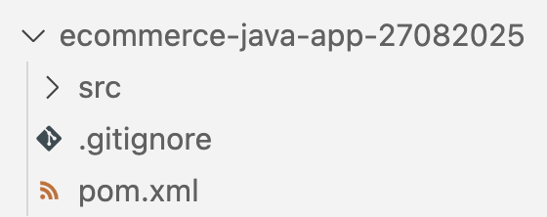

- Here is a quick guide to get started with Maven - https://maven.apache.org/guides/getting-started/
- Next, we will create a Dockerfile to build the Docker image of this application. The Dockerfile has the steps to run the application as the docker container.
- Add a Dockerfile (without any extension)
- Add the following code

# Multi-stage build for Spring Boot application

# Stage 1: Build stage
FROM maven:3.9.9-eclipse-temurin-21 AS builder

LABEL maintainer="saurabh@uptut.com"

# Set the working directory inside the container
WORKDIR /app

# Copy the pom.xml to the container first (for better layer caching)
COPY pom.xml .

# Download dependencies (this layer will be cached if pom.xml doesn't change)
RUN mvn dependency:go-offline -B

# Copy the source code to the container
COPY src ./src

# Build the application using Maven
RUN mvn package -DskipTests

# Stage 2: Runtime stage
FROM eclipse-temurin:21-jre-alpine AS runtime

LABEL maintainer="Saurabh"

# Create a non-root user for security
RUN addgroup -g 1001 -S appgroup && \
adduser -u 1001 -S appuser -G appgroup

# Set the working directory inside the container
WORKDIR /app

# Copy the JAR file from the builder stage
COPY --from=builder /app/target/ecommerce-app-1.1-SNAPSHOT.jar app.jar

# Change ownership of the app directory to the non-root user
RUN chown -R appuser:appgroup /app

# Switch to the non-root user
USER appuser

# Expose the port the app runs on
EXPOSE 8080

# Command to run the application
CMD ["java", "-jar", "app.jar"]

Code Explanation
It uses a multi-stage build:
- Stage 1 (“builder”) compiles your Spring Boot app with Maven.
- Stage 2 (“runtime”) is a tiny image that only contains Java to run the finished JAR—no build tools—so it’s smaller and safer.
Stage 1 — Build the app
FROM maven:3.9.9-eclipse-temurin-21 AS builder

Start from an image that already has Maven + Java 21. Name this stage builder.
WORKDIR /app
COPY pom.xml .
RUN mvn dependency:go-offline -B

Work inside /app. Copy pom.xml first and pre-download all dependencies.
Why? Docker caches this layer, so if your code changes but pom.xml doesn’t, you avoid re-downloading everything.
COPY src ./src
RUN mvn package -DskipTests

Copy your source code and build the JAR (skip tests to speed it up). The result lands in target/.
Stage 2 — Run the app (small, production-friendly)
FROM eclipse-temurin:21-jre-alpine AS runtime

Use a lightweight Java 21 JRE image (Alpine). No Maven here.
RUN addgroup -g 1001 -S appgroup && \
adduser -u 1001 -S appuser -G appgroup

Create a non-root user (safer than running as root).
WORKDIR /app
COPY --from=builder /app/target/ecommerce-app-1.1-SNAPSHOT.jar app.jar
RUN chown -R appuser:appgroup /app
USER appuser

Work in /app, copy the built JAR from the builder stage, fix ownership, and switch to the non-root user.
EXPOSE 8080
CMD ["java", "-jar", "app.jar"]

Document that the app listens on 8080, and define how to start it.

Why is this good?
- Smaller image: you don’t ship Maven/compilers to production.
- Faster pulls & deploys: fewer MBs.
- More secure: runs as a non-root user.
- Quicker rebuilds: dependency caching via pom.xml first + go-offline.
Things to watch
- JAR name: Make sure ecommerce-app-1.1-SNAPSHOT.jar matches your real artifact. Consider COPY --from=builder /app/target/*.jar app.jar to avoid version mismatches.

Build the docker image
Run the following command to build the docker image

docker build -t <dockerhub_username>/java-app-ms .

Run the docker container

docker run -d -p 80:8080 <dockerhub_username>/java-app-ms

docker ps

Open browser and navigate to http://localhost

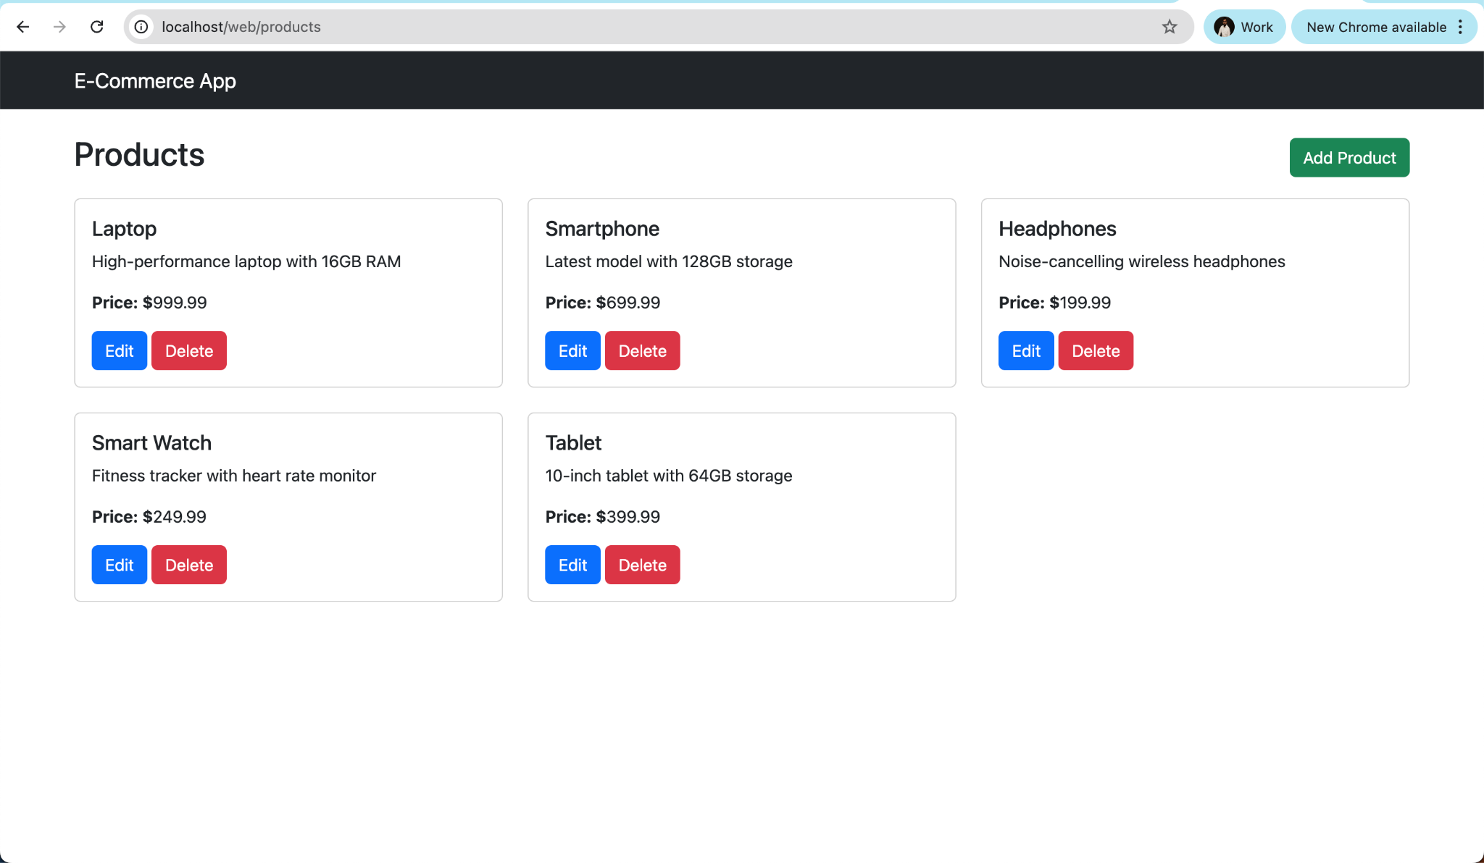

Congratulations, you have successfully build a docker image to run it as docker container!

